|  |
| --- |
|  |
| Econ 321 Mini Project |
| Used 2014 BMW 3 Series Sedan Pricing Model |
|  |
| **Kevin Cho Wong 20369345 krchowon** |
|  |

|  |
| --- |
|  |

# Executive Summary

This study focuses on exploring the pricing relationships of used BMW 2014 3 Series sedan in the Toronto used car market. This study was able to narrow down the key factors in consideration when market participants price the cars to kilometres driven, drive train, car model, and exterior colour. These main factors were derived by stripping parameters which had low statistical significance in the explaining prices and weak qualitative connections in the relationship.

# Characteristic of populations

The population we are exploring is the used car market for used BMW 2014 3 Series sedan in Toronto. The Toronto used car market is characterized as any used car dealer within 75 km from downtown which is still within the same jurisdictions of Ontario. Note that by design, the model would not explain any pricing discrepancies in taxing regulations outside the borders of Ontario or discrepancies caused by currency due to the focus of the study.

The 2014 BMW 3 Series Sedan has 3 models, 320I, 328I and the 335I. As the number model increase, the specifications of the car is cranked up with more horse power and amenities. Look and feel of the car for each model can be customized with 4 different packages to upgrade from its basic look; Sports, Modern, Luxury and M Performance.

# Sampling Method

With a mandate to capture a random representative sample of used BMW 2014 3 series sedan in the Toronto car market, I decided to use online advertisements as a reliable sampling method. To alleviate biases, multiple sources were searched for advertisement with sufficient information on the used cars. Auto Trader, Car Guru and Kijiji were the main sources for our sample data.

From each used car posting, the available cardinal information we could extract are kilometers traveled and warranty in years. Categorical data available for collection on used BMW 2014 3 series are drivetrain, model, line, interior colour and exterior colour. Limitations to our sampling soon emerged as I noticed the Toronto used car markets has no warranted cars. Thus, by characteristic of the market, there is no opportunity to factor warranty into pricing of used cars.

Other data sets which could be collected were omitted because of 100% co-linearity. These data sets include city fuel economy, highway fuel economy, and engine. Information on these attributes is a one to one mapping to the model of the car.

Biases that may be introduced by limitation of our sampling method may rise from a few sources. First limitation of sampling from online price advertisements is that we consciously omit local used car dealers and small shops in Toronto which do not participate in the online market place. However, we do not expect large deviations from excluding those participants since our sample size is fairly large, we can assume with a large degree of confidence that the pricing expectations of these omitted market participants will follow the same distribution.

Another limitation imposed by the sampling method is the omittance of other significant factors that affect prices. In particular, the omitted factors are those which could not be collected from the sample and is not captured by the collected set of data thus far. An example of a potential significant variable that would affect the car may be *Dollar Value of Car Amenities*. This variable would reflect the additional payment for amenities such as GPS, rear view camera and a sun roof, data which is not reported in car postings, and may have significant impact on affecting the price of the car.   
  
Discussion of Relationship

The relationship of interest is how market participants in the Toronto used car market price the value of the BMW 2014 3 series. In particular, what factors and weights are considered significant in pricing expectations?

Some available factors that may contribute to used car pricings are warranty, kilometers travelled, model, line, interior colour, exterior colours and drivetrain. Notice that warranty and kilometres are the only cardinal data sets which can help explain variations in price. Later investigations in sampling data from Toronto used car markets shows there are no warranted used cars. Thus, by characteristic of the market, there is no opportunity to factor warranty into pricing of used cars.

Viable relationships that would affect the pricing of used cars are between kilometers travelled and categorical variables model, line, interior colour, exterior colour and drivetrain. Fortunately, other considerations are categorical, so one only needs to assess the linearity of the relationship of kilometers traveled with price expectations. An intuitive justification for the linear model is that when all else equal, an extra accumulation of kilometres travelled should decrease the price of the car should be consistent across all odometer readings because there is a lack of sufficient evidence that price changes would be more steep or flat at different levels. This will be further examined in our model selection process. Further qualitative characteristics is the potential introduction of heteroskedasticity for premium BMW 3 series as we anticipate lower liquidity in premium used cars will lead to higher price variations.

# Model Selection

Our preliminary model fits all available factors for explaining used car prices. Thus we ran used BMW 2014 3 series sedans on kilometers driven, model, line, interior colour, exterior and if it comes with xDrive. For the categorical variables, we chose our base reference as the cheapest model with the most common customization. Thus our base case represents a used 2014 BMW 320I model with the base line body kit, black interior furnishing, white exterior and no xDrive.

A quick check of the fitted residual plots and normal QQ plots raises some concerns, however performing the Breush-Pagan Test by running the errors with all of the factors fails to reject the null hypothesis of homoscedasticity (see Appendix 2). Thus we can be assured to use F-test and T-test confidently.

From the preliminary model with all available repressors (see Appendix 1), kilometers driven results in a negative relationship with price. This is aligned with our intuitive expectations as higher longer distance travelled depreciates the quality of the car through use. The model estimates that when all else equal, every 100 km driven, the price of the used car decreases by $26.64. Having xDrive on the used car in this model configuration is not statistically significant even at the 10% level. Thus, xDrive does not have a statistically significant impact on price of used BMWs when all factors are taken into account. As users choose higher models for used cars, it appears only the 335I model is statistically significant in impacting pricing, whereas the 328I model does not seem to be priced statistically different the 320I model. Line of the car has statistically significant impact in pricing the BMW only if the line is a Sports Package. For the colouring of the car, it appears that only red for interior or exterior of the car is statistically significant and impacting the price of the car at 10%.

Although the model has a large variety of variables with thorough explanatory power, it is far too complacent because of fear of the omitted variable bias. The motivation to streamline the model is to produce a better fit for our data which is evaluated among adjusted R2 and characteristics of the relationship. Extra variables in a model potentially introduce bias if there exist co-linearity or increase variance for estimators. In practice, extra parameters is more demanding on sampling procedures and can also be a source of error.

The first variable we assessed was the interior colour. Inferring from the market characteristics, interior colour seemed to be the least significant out of all the other factors in price impact. In particular, the colours of the interior of the car are not associated to any measurable costs that can systematically impact price since its value to market participants is subjective. Unlike exterior colour, I suspect that the level of importance placed on the colouring of the interior is insufficient in surfacing this characteristic to market participants as a whole in the used car market. Further analysis with the F-test is aligned with this intuition so a decision to remove interior colour from the model was enacted (see Appendix 3 – Model2). The compromise in this model selection is the adjusted R2, where 0.0091 of explained variation is sacrificed. This may seem like a small price to pay however, as we can be more confident with this model configuration. Notice now that the two factors, whether the car has xDrive and if the car line is Luxury, which were statistically insignificant in the preliminary model, now has explanatory power for 10% confidence.

Further refinement the model tests the other factors with similar methodology. From Model 2, Kilometers travel and xDrive are both statistically significant since p-value is less than 1% and 10% respectively. So both parameters should remain in the model. An F-Test to assess statistical impact of exterior colour as a whole turns out to be significant at 5% level (see Appendix 4). Testing the statistical significance of car models also proved to be statistically significant (see Appendix 5).

Performing the F-Test on the line of the car shows that the car line does not statistically significantly impact the price of the used car (See Appendix 6). This test may signify a characteristic of market participants to weigh car models significantly more than car lines when pricing used BMW 3 series. Intuitively, there is a strong case to still include line as part of the factors since each line has a concrete cost attached to the upgrade. However a systematic perspective views the line of the car as statistically insignificant when Kilometres driven, if the car has xDrive, Model of the car, and exterior colour have already been factored in. By choosing to remove car line from our pricing model, we sacrifice 0.0124 of adjusted R2 from our second Model configuration(model which removed interior colour of a car from the preliminary model). However, xDrive in this model configuration has gone from 10% statistically significant to a 0.1% significance. Weighing these considerations, there is a strong case that the systematic selection of optimal parameters produces a model with superior explanatory power despite sacrificing a bit of adjusted R2 explanatory power. Thus we move forward in removing removing car line from our model.

Thus our finalized model for the used 2014 BMW 3 Series Sedan pricing model (see Appendix 6) isolates the main factors contributing to the price of the used car to be;

Price = ϐ0   
 + ϐ1*(KM)  
 + ϐ2*(xDrive)  
 + ϐ3*(Model328I) + ϐ4*(Model335I)   
 + ϐ5*(Ex_ColourBlack) + ϐ6*(Ex_ColourGrey) + ϐ7*(Ex_ColourRed) + ϐ8*(Ex_ColourSilver)

# Results

The final model describes the pricing relationship of used 2014 BMW 3 Series sedan to 4 main considerations; kilometres driven, whether the car has xDrive, the model type of the car, and the exterior colour of the car. A R2 of 0.7947 and an adjusted R2 of 0.7573 for the model infers that there is strong explanatory power from our model.

The reference car for our model states that for a white BMW 320I series car with no xDrive or no logged travelled distance costs $36, 260. This estimate is aligned with our expectations as a new BMW 320I sedan is advertised as $35,990 on the official BMW website. The model also predicts, with 0.1% statistical significance, that for each 100km driven on the car the price of the used BMW decreases by $27.18. The average kilometers travelled in our sample is 15440.92km. This would price the white BMW 320I series car with no xDrive at $32,063, which is within reasonable bounds of the market. Overall Model of the car was tested to have significant impact on pricing of the car. However, only the 335I model has a statistical impact on the price, amounting to a $13,520 premium over the 320I model. The model does not make any material difference between the 328I and the 320I in pricing. Overall exterior colours of the car also plays a significant role in pricing, however only Red BMWs appear to have significant pricing affects, amounting to an $8,607 premium over a white BMW. Other exterior colours, such as grey, black and silver, do not hold any significant price impact. This premium seems slightly too high, and could be capturing sporty variations of the car which are not captured by the current factors.

Through this study, some interesting insight into the Toronto used car market was discovered. Many of the factors discovered had sound implications in pricing used BMW 3 series. This model helps explain a significant amount of pricing anomalies and also provides insight on areas of improvement or limitations.

# Bibliography

"IMPOSSIBLY BETTER." BMW 3 Series Sedan. N.p., n.d. Web. 25 Mar. 2015.  
 http://www.bmw.ca/ca/en/newvehicles/3series/sedan/2011/showroom/index.html

# Appendix

## 1.Preliminary Model

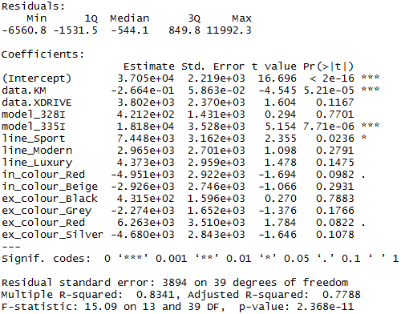

2. Heteroskedasticity Test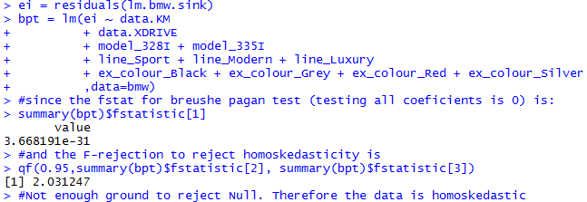  
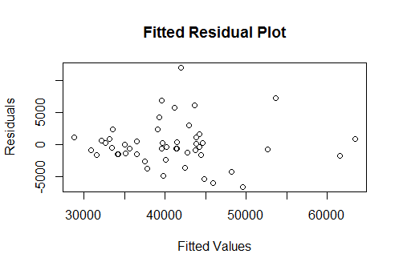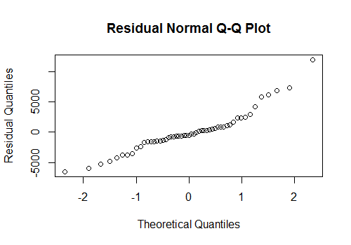

3. Model2 - Taking out Interior Colour as a regressor  
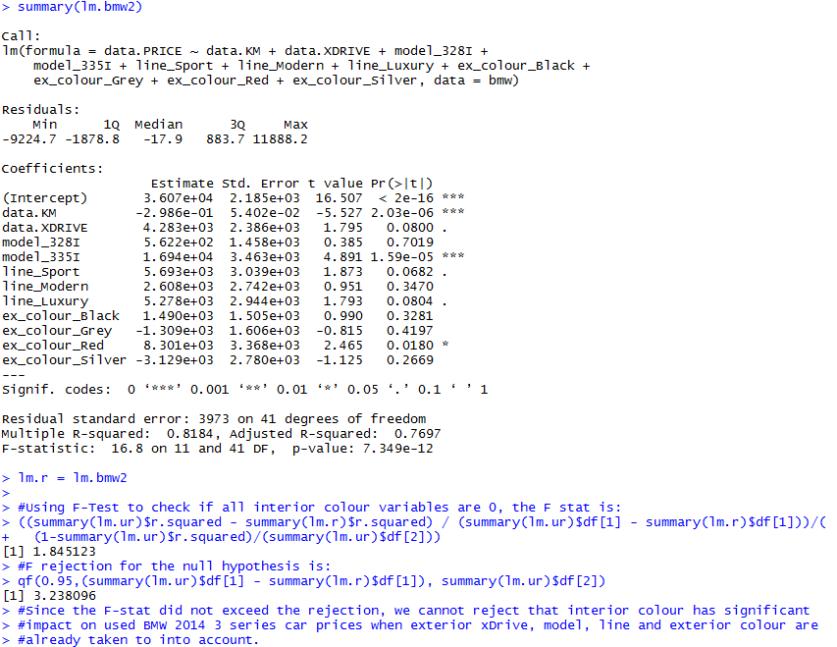

## 4. **Testing Exterior Colour**

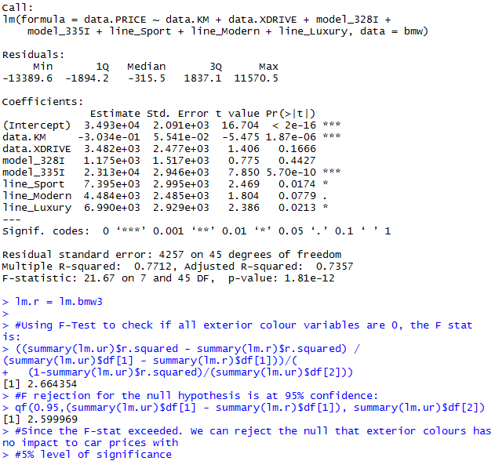

5. F-Test for Car Model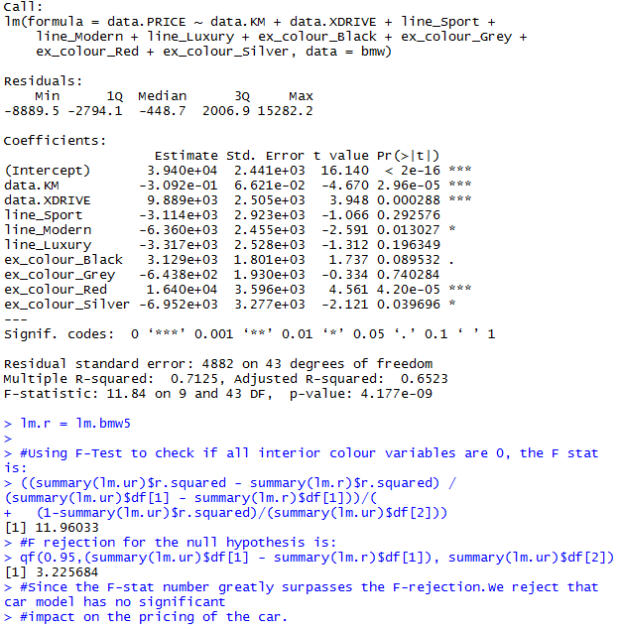  
6. Final Price Model for used 2014 BMW 3 Series Sedan & F-Test for Line of the Car  
